SIGA Academy

FENTRIM WORKSHOP
  - GREAT BRITAIN
DETAILS

£160 per Person
Inclusive:
- Workshop
- 2 Dinner
- Accommodation incl. breakfast
- Excursion Lucerne
- 2 Lunch
- Certificate
- samples
- Arrival, Departure
Exclusive:
- Arrival, Departure to the airport

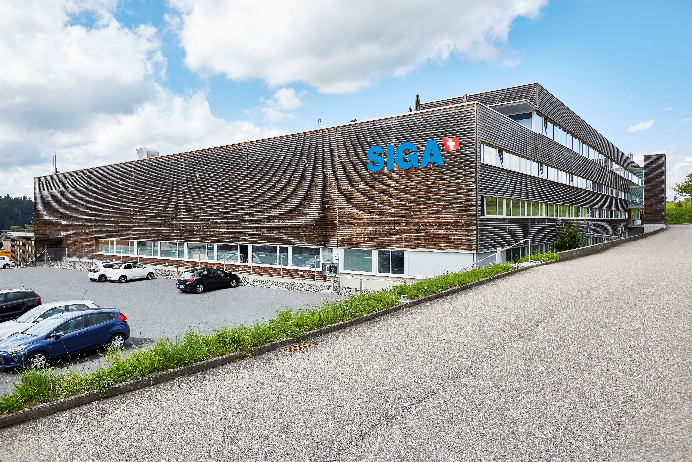

REGISTRATION

DATE
Monday, 16th April 2018 Arrival, Dinner
Tuesday, 17th April 2018 Workshop, Dinner
Wednesday, 18th April 2018 Excursion, Departure

REFERENCE

CWS109278 Registration deadline: 05/03/2018

TRAVEL
Airport Manchester Airport London Airport Glasgow

CLIENT Client-No.:
COMPANY
STREET
ZIP/TOWN
E-MAIL

PARTICIPANT (max. 2 Person per Company)

1.
Surname/ Name/ Function

2.
Surname/ Name/ Function
General terms and conditions of the SIGA Academy Workshop Trip  1. Conclusion of contract  By completing the SIGA registration form the customer confirms his acceptance of the general terms and conditions of the SIGA Academy Workshop Trip and commits himself to taking part in the workshop. The contract is concluded when the signed form is given to the trainer or sent by email.  2. Terms of payment  After registration, the participant receives confirmation of his registration by email and an invoice is sent by post.  3. Scope of the service provided  The workshop fee covers the above-mentioned services: | 4. Cancellation and rebooking  No costs are refunded after registration has been made.  All costs resulting from cancellation or rebooking will be charged to the participant.  Non-participation or discontinuation of the workshop are regarded as cancellation.  When participants travel by air any change of name is equal to a cancellation and rebooking of the flight.  If the participant does not take the outward flight, the return flight will be canceled automatically.  5. Implementation provisions  SIGA AG may decide to cancel a workshop trip if the number of registrations is insufficient. Persons who have already registered will be informed of the possible cancellation in good time. Workshop fees already paid will be refunded.  The participant is responsible for the provision of complete and correct travel formalities (passport/identity documents), and for insurance.  SIGA accepts no liability for additional costs caused by the participants during travel, the excursion etc.  6. Jurisdiction, applicable law  This contract is subject to Swiss law. The place of jurisdiction is Willisau LU.

